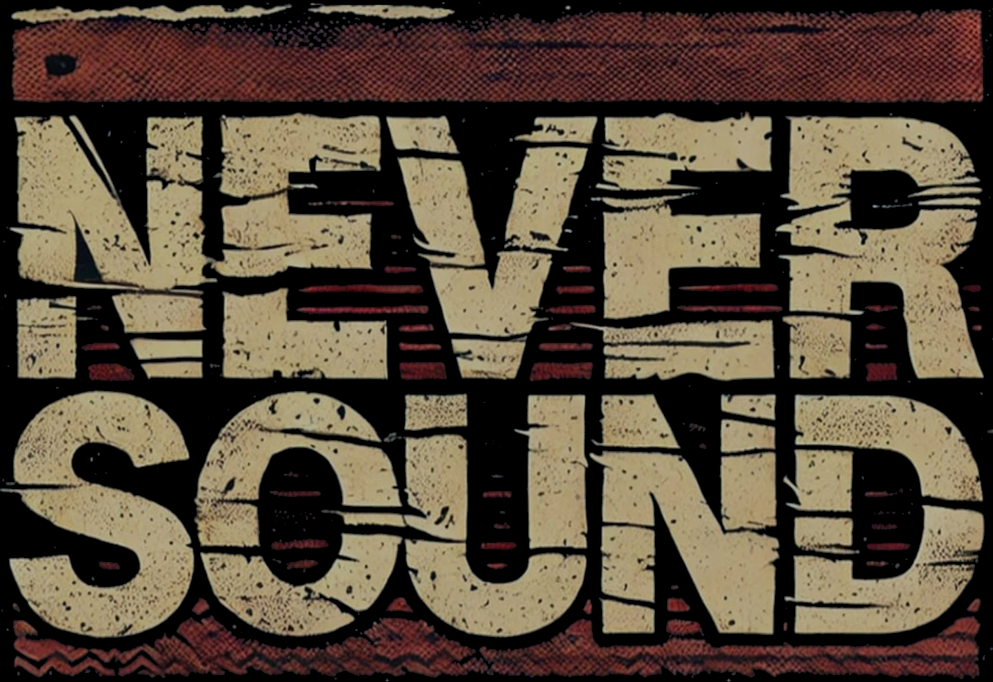
Tech Spec
Name | Plays | Amp | Outputs | Monitoring
James Griffith | Vocals | FOH | 1 X MIC | Vox - High  Guitar - Mid  Bass - Low  Drums - Mid
Hannah Goss | Guitar/Backing Vocals | Marshall 1x12 combo | 1 X Cab MIC  1 X Vocal MIC | Vox: high  Guitar: mid  Bass: mid  Drums: low
Dom Allison | Bass Guitar | FOH | 1 X XLR DI from pedalboard | Vox - Low  Guitar - Mid  Bass - High  Drums - Mid
Oscar Wallbank | Drums | FOH | 1 X Kick  1 X Snare  3 X Rack Toms  1 X Floor Tom  + Overheads | Vox - Low  Guitar - Low  Bass - High  Drums - High
IEMS:
Iems can be ran with either individual mixes 4X Transceivers + 4X Receivers
OR
1X Transceiver + 4X Receivers with a singular Mono monitoring mix

